MySQL Assignment 1 – DDL Commands & Constraints
SUBMITTED RESHMA JOY
DDL Commands :
- Table Creation (CREATE):
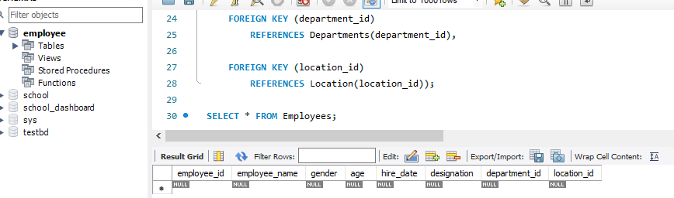
2.Table Alteration (ALTER):
Add a new column named "email" to the Employees table to store
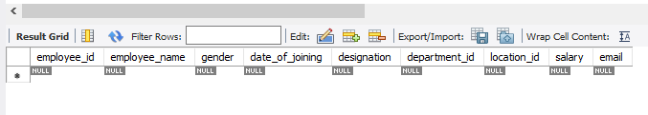
employee email addresses.

Modify the data type of the "designation" column in the Employees
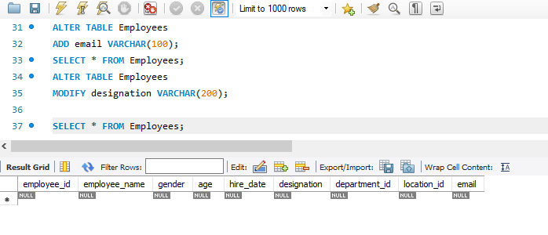
table to support a wider range of values.

Drop the “age” column from the Employees table.
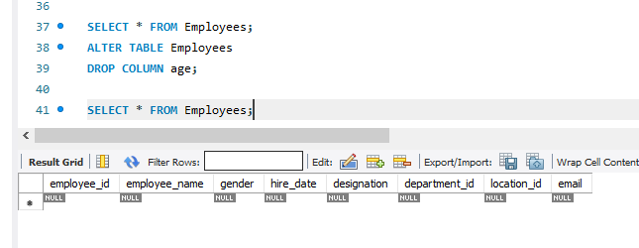

Rename the “hire_date” column to “date_of_joining”
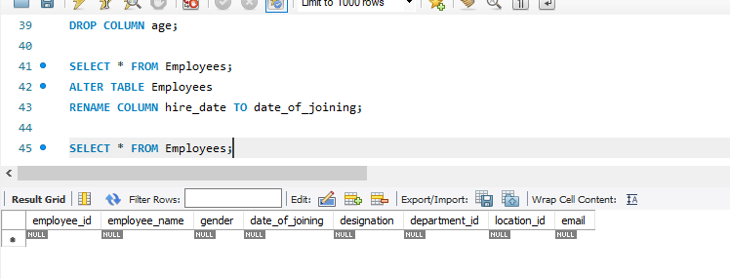
3.Table Renaming (RENAME):
Rename the "Departments" table to "Departments_Info".
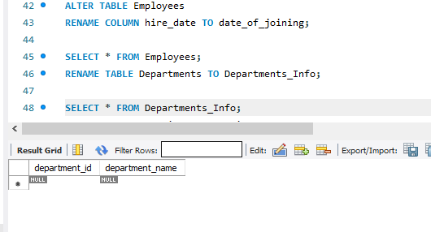

Rename the "Location" table to "Locations".
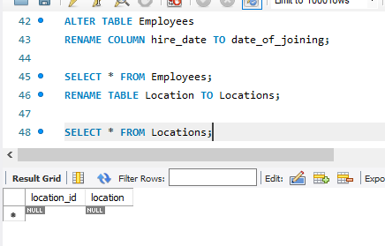

4. Table Truncation (TRUNCATE): Write an SQL statement to truncate the
Employees table.
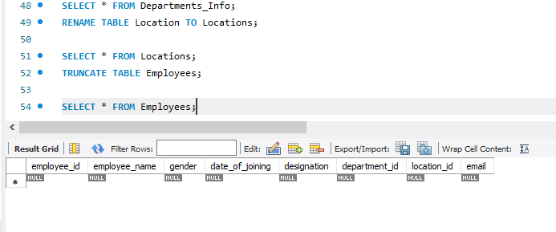

Database & Table Dropping (DROP): Write the SQL statements to drop the
Employees table and then the “employee” database.
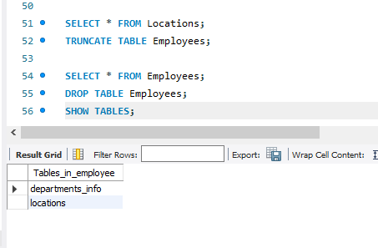
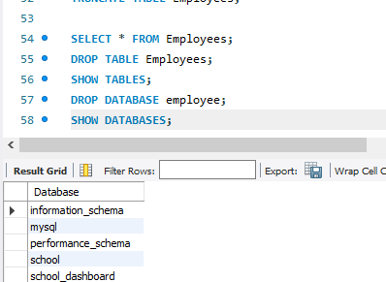

Constraints:
1. Database Recreation:

⦿ Drop the 'employee' database if it exists and recreate it using the
provided schema, ensuring that all tables are created with the
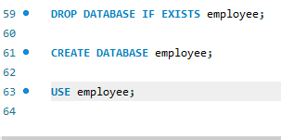
appropriate constraints as instructed.

- Departments Table:
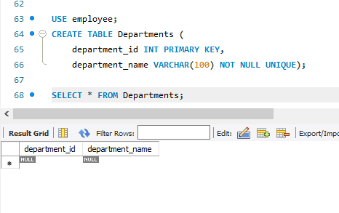

- Location Table:
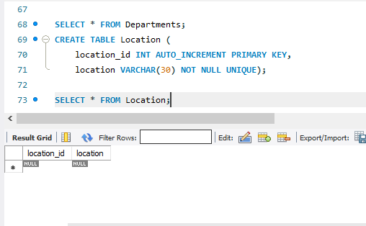

- Employees Table:
